**Project Details**

|  |  |
| --- | --- |
| Project number | *9* |
| Project title | *Mega store corporation* |
| Corresponding TA\LA | *LA\Alia Magdy* |
| Deliverable | *3* |

**Team Details**

|  |  |  |
| --- | --- | --- |
| **Student ID** | **Student name** | **Lab Group** |
| 20201203 | Nourhan Amr Abd El-Wahab | S6 |
| 20201189 | Nada Emad Mohammed | S8 |
| 20201041 | Aya Hasanin Sayed | S6 |
| 20201191 | Nada Mohammed Ahmed | S1 |
| 20200606 | Nour Yasser Mahmoud | S6 |
| 20201182 | Mai Tarek Ahmed | S8 |
| 20200522 | Mariam Tarek Galal | S5 |

**DESIGN THE ENVIRONMENT**

1. **Using the project description then answer the following questions:**
2. **With what external systems and databases will the system under development interact?**

* External Systems: Credit Card System, Google Maps.

**Databases:**

* + - * + Customer (username, country, product list)
* Admin (admin name, id)
* Payment (product, amount, method)
* Return product (purchase date, product, request state)
* Warehouse (location, supplier)
* Product (purchase date, name, code, category

1. **What devices will be used for automated inputs and outputs?**

* Devices:

Input Devices: Mobile phones, Tablets, Laptops, Desktop computers, Keyboard,

Bar code reader, QR code reader.

Output Devices: Screens Printers.

1. **What user-interface technology will be used?** 
   1. Where users will be located?
2. The users are in their homes or work and use the application of the store

to order online but they should enter their location first and can order from the website of their countries.

b. they may go to the store to buy onsite

2. What hardware devices will users use?

a. the users use Mobile, Tablet, and Laptop….

**THE USER & SYSTEM INTERFACES**

**a. Identify the various screens and forms that may be needed for the user interface.**

. Welcome screen: Input screen to welcome the customer and view options in the megastore

. Payment form: Input screen for choosing the payment method

. Visa form: Input screen to determine credit card info (card number, card password)

. Amount screen: Output screen to display the amount required for payment

. Confirm screen: Output screen to confirm the payment

. Points screen: Output screen to display the required points and updated points

. Return form: Input screen to determine the returned product info

. Response screen: Output screen to respond to the return request

. Manage Warehouse Form: input screen to know which product has a shortage and which supplier will bring it

. Warehouse screen: Output screen to confirm the product will be sent

1. **From use case diagrams developed during the analysis phase of your project which related to the screens and forms identified in (2. a):**
2. **Create a good menu design by following the principles you studied. This should start by defining how use cases are grouped inside a menu in a tabular format, which is followed by the actual menu design and defining which menu style will be used.**

|  |  |  |
| --- | --- | --- |
| **Menu**  **description** | **Choices (user-cases)** | **Intended Users** |
| Product | 1. Search For Product 2. Buy product 3. Return the Product 4. Check to return products | * Customer * Organizer * Admin |
| Payment | 1. Pay By Visa 2. Pay By Cash 3. Pay By Points | * Customer |
| Offers | 1. Display Offers 2. Use Offers 3. Announce Offers | * Customer * Admin |
| Category | 1. Choose a Category 2. Manage Category | * Customer * Organizer |
| Services | 1. Enhance Services 2. Provide Different Services | * Organizer * Admin |
| Warehouses | 1. Manage Warehouses | * Admin |

**Menu Style: Horizontal Drop-Down Menu**

1. **screens and forms identified in (2.a) create a Storyboard that captures the sequences of events. Storyboards may be designed using wireframe tools or low-fidelity paper sketches, e.g., pencil tools, power points, etc.**

**Story Board for Payment**

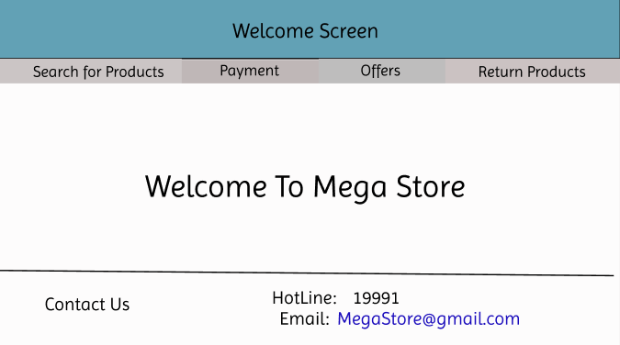

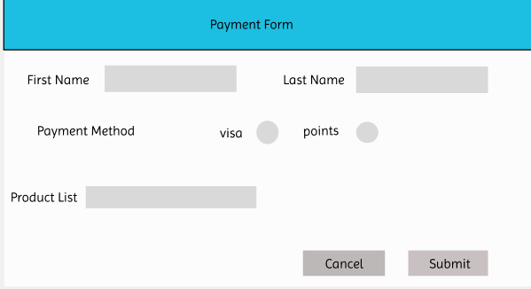**2)**

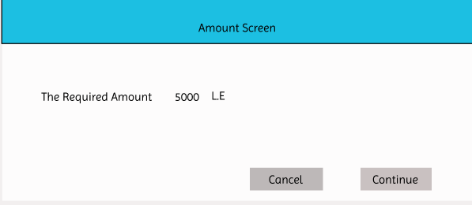 **3)**

**4)**

**5)**

**Story Board for Return Products**

**1)**

**2)**

**3)**

**Story Board for Manage Warehouses**

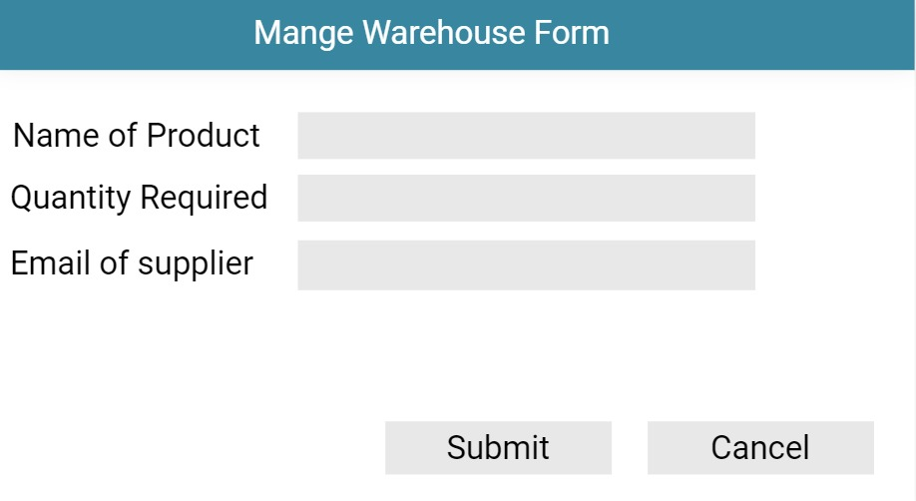

**1)**

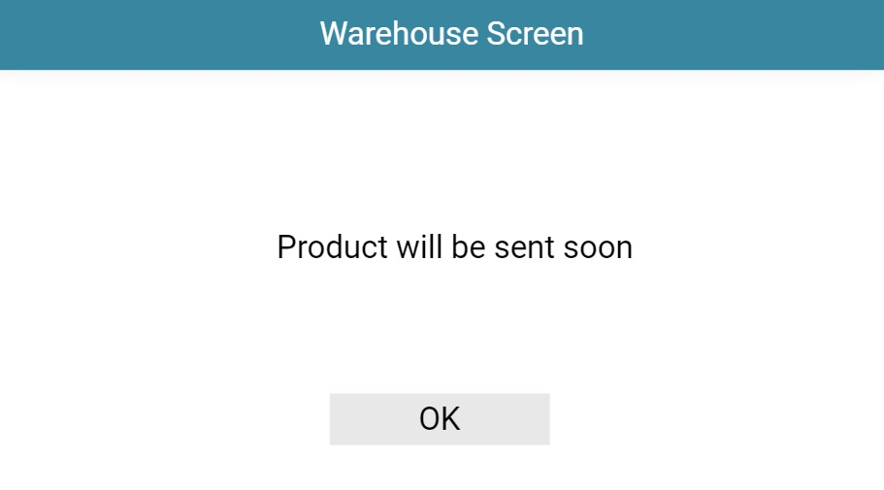**2)**

1. **Design a web-based user interface (screen) and mobile/tablet interface for one of the screens from (2.a).**

**Mobile Interface**

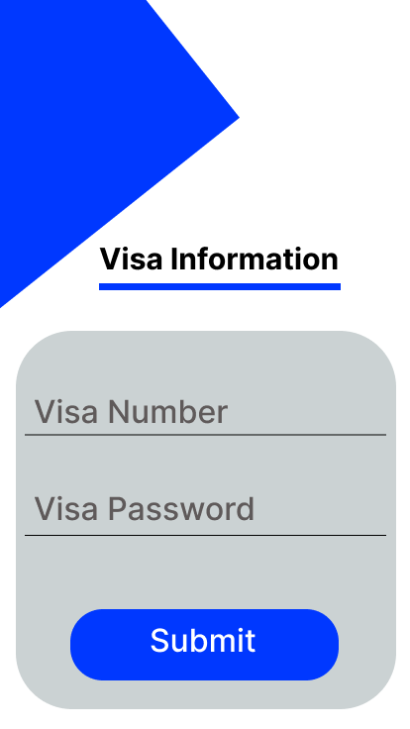

**Web site Interface**

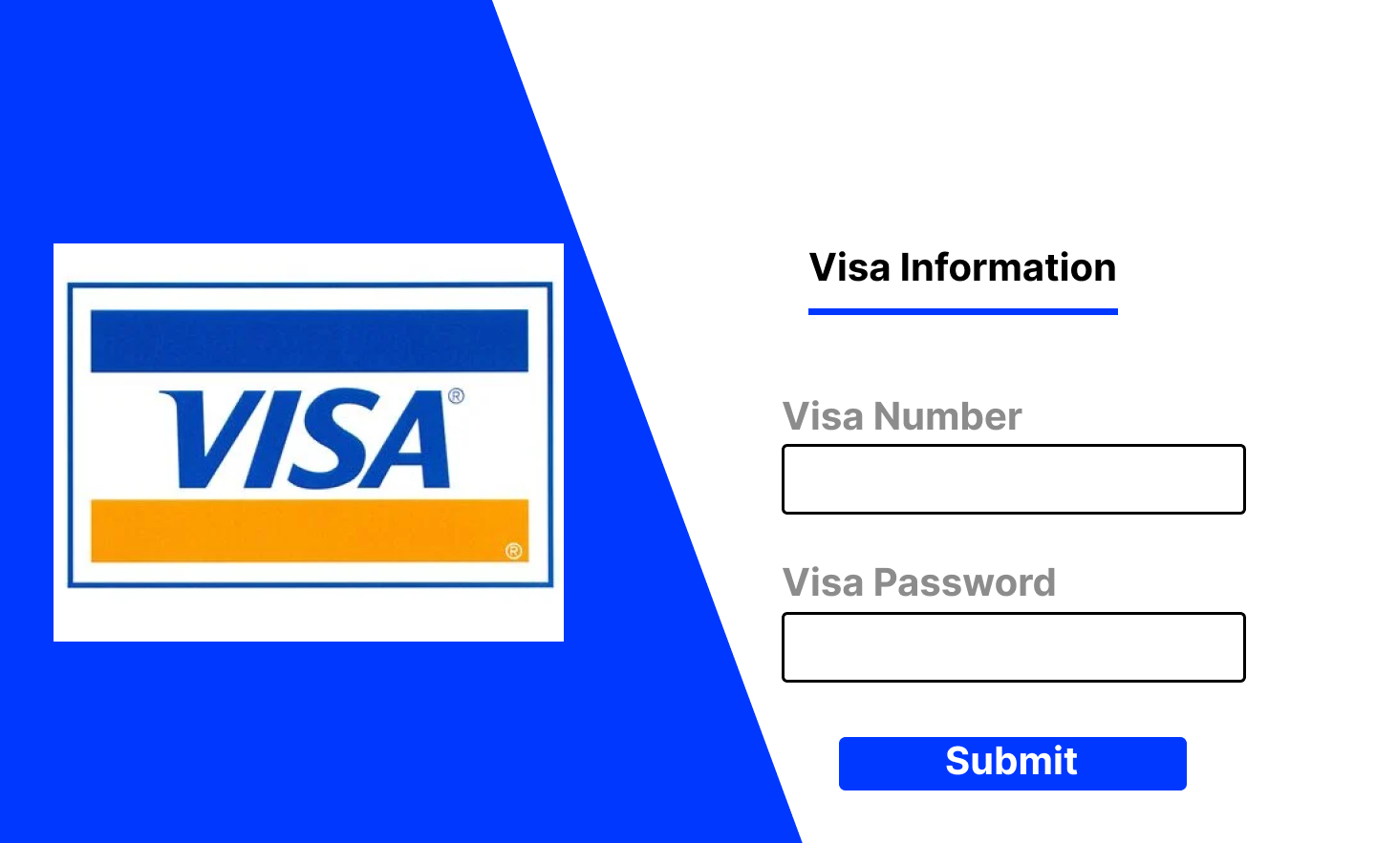

1. **Consider all User Interface Design Guidelines you studied and show how they addressed in your screens**

NTERNAL REPORT: a report generated by the system that shows current applied Refunds Requests that need to be checked and proceeded with.

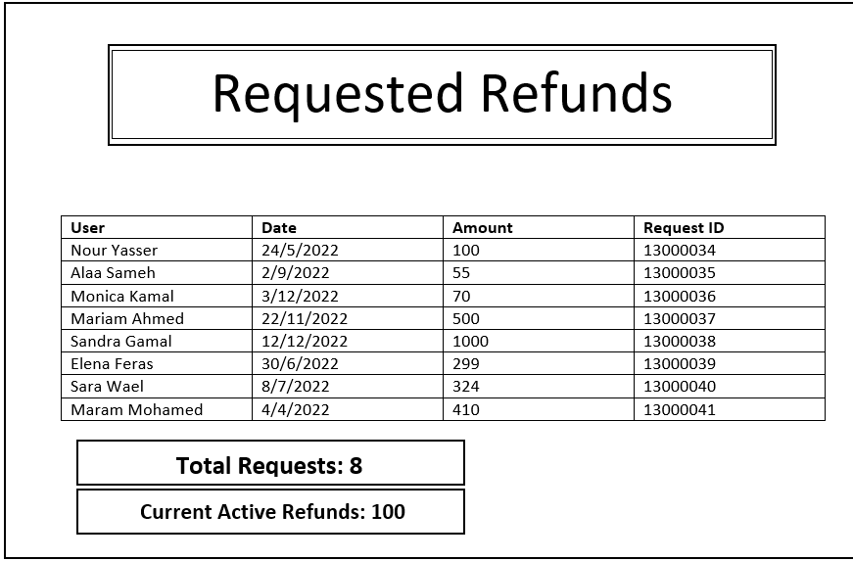

EXTERNAL REPORTS: Report generated to customer to check his past ordered products and its amount and price paid

